Tiny Tapeout Project – AXI Stream to UART Communication System

Overview:

- The AXI Stream to UART system transfers parallel data from an AXI-Stream interface to a UART serial channel.
- Data send by the AXI-Stream master is pushed into a synchronous FIFO buffer. The FIFO output is then serialized and transmitted by the UART transmitter.
- On the receiver side, the UART receiver deserializes the data, checks parity, and outputs parallel data.

Block Diagram:
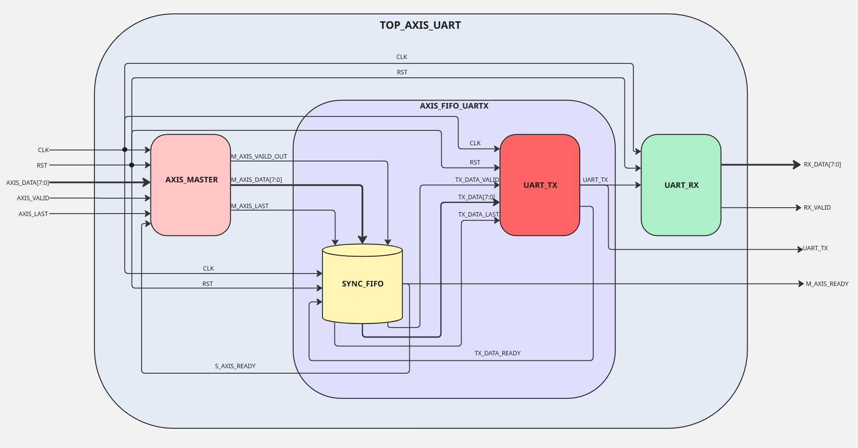

Functionality:

Module | Function
AXIS Master Input | sends valid data packets for transmission using AXI Stream handshaking signals (valid, ready, last).
Synchronous FIFO | Buffers AXI Stream data to handle speed differences between producer (AXIS Master) and consumer (UART TX). Supports parallel read/write operations and “full/empty” detection.
UART Transmitter | Converts parallel FIFO data into serial format as per configured baud rate. Supports even parity generation.
UART Receiver | Deserializes received UART stream, reconstructs parallel data, verifies parity, and asserts rx_valid when data is ready and parity is verified.

Pins:

Pin Name | Direction | Width | Function
clk | Input | 1 | Clock Signal
rst | Input | 1 | Active High Synchronous Reset
axis_data | Input | 8 | Parallel input data from AXI Stream master
axis_valid | Input | 1 | AXI Stream valid signal – indicates valid data for axis_data
axis_last | Input | 1 | Indicates last data in a frame
m_axis_ready | Output | 1 | Indicates that system is ready to accept new AXI data i.e. the FIFO is not full.
uart_tx | Output | 1 | UART serial transmit line
rx_valid | Output | 1 | High for one clock cycle when new data is received successfully
rx_data | Output | 8 | Parallel data after UART reception

Operating Sequence:

- AXI Input Stage: AXI master asserts axis_valid with data on axis_data. When m_axis_ready is high, data is accepted and written to FIFO (axis_last is asserted after the last byte is sent with 1 clock cycle delay).

- FIFO Buffering: FIFO stores incoming bytes until the UART transmitter is ready to send. Read and write can occur simultaneously.

- UART Transmission:
- Each byte is serialized at 115200 baud.
- Start bit (0), data bits (8), parity bit, and stop bit (1) are sent.
- tx_data_ready indicates when UART can accept new data.

- UART Reception:
- Receiver detects start bit, samples bits at mid-baud intervals.
- Extracts data, verifies parity, and asserts rx_valid.

Design Parameters:

Parameter | Value
Data Bits | 8 bits per UART frame
Baud Rate | 115200
Clock Frequency | 50 Mhz
FIFO Depth | 8 bytes

Other Details:

- AXI Stream Protocol – The data transfer takes place only when VALID(axis_valid) = 1 and READY(m_axis_ready) = 1.

- UART Frame Format –
Start Bit
Stop Bit
Parity Bit
Data Bits

AXI stream protocol channels

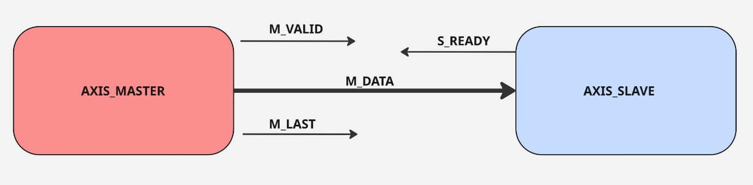

M_valid :indicates valid input data for axis_data.

M_data : 8 bit input parallel data.

M_last: indicate last byte of the input data.

S_ready : signal used for handshake indicates that system is ready to accept new AXI data.

